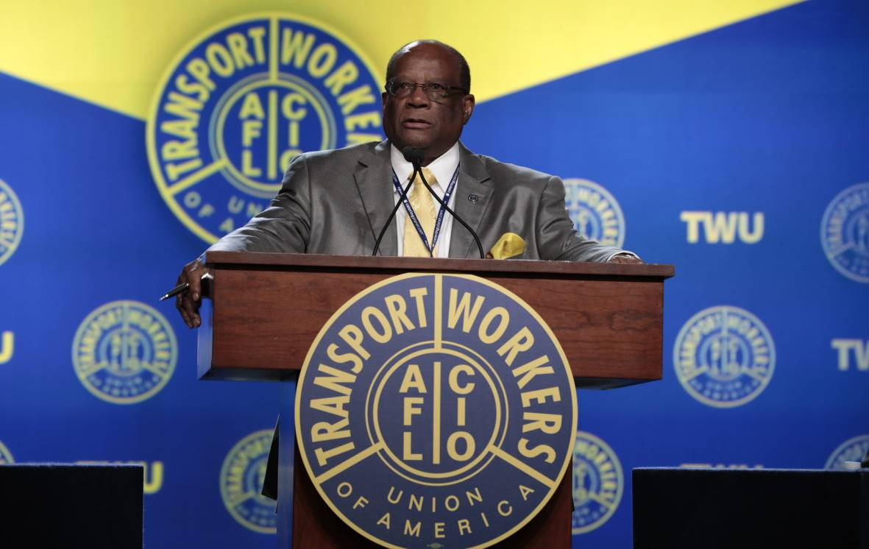

THE JOHN W. BLAND MEMORIAL SCHOLARSHIP APPLICATION
Fighting for the rights and privileges of others was a legacy of John W. Bland. He also found joy in assisting youth to seek higher education/vocation. This scholarship is available to 2026 Bethany Baptist Church qualifying high school graduates.

The Criteria for Scholarship Qualification

- Must be a regular attending member of Bethany Bapt. Church.

- Must have been a member for at least six (6) months prior to the scholarship
application’s deadline date.

- Must be an active participant (attending/participating at least once monthly) for at least six (6) months, in at least one church activity/ministry.

- Must present official transcript with application on or before April 26,2026 to
Mother BETTY BLAND
bblandjo@aol.com

- Must enroll in an institution of higher learning (university or vocational). Registration receipt and class schedule must be presented to BETTY BLAND, as proof of enrollment, before money is disbursed.

THE JOHN W. BLAND MEMORIAL SCHOLARSHIP

Scholarship Application

NAME_________________________________ DATE_________________

ADDRESS______________________________ PHONE________________

CITY___________________________________ ZIP CODE______________

FATHER/GUARDIAN_______________________________________________

MOTHER/GUARDIAN______________________________________________

HAVE YOU APPLIED FOR ADMISSION TO A COLLEGE/VOCATIONAL SCHOOL?
IF YES, WHICH ONE(S) HAVE YOU BEEN ACCEPTED?

________________________________________ _________________________
_____________________________________ _________________________
_____________________________________ _________________________

ARE YOU A REGULARLY ATTENDING MEMBER OF BETHANY BAPTIST? _________

WHEN DID YOU UNITE WITH BETHANY? __________________________________

YOU ARE AN ACTIVE MEMBER (attending/participating at least twice per month for the past six months) OF WHAT BETHANY ACTIVITY/MINISTRY? If you are involved in 2 ministries, you need two signatures below.
_____________________________________________________________________

TEACHER’S/DIRECTOR’S/MINISTER’S SIGNATURE(s)___________________________________________________________

RETURN COMPLETED APPLICATION WITH OFFICIAL TRANSCRIPT ON OR BEFORE APRIL 26, 2026 TO MOTHER BETTY BLAND

I have answered each question truthfully and to the best of my knowledge.

APPLICANT’S SIGNATURE DATE

